Name of Park Gardening Team
Dow Park

Splude’s Place
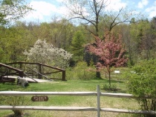
Doolan’s Game Park

Center Island
Agassiz Island
School Island
Wolcott Pines
Transfer Station
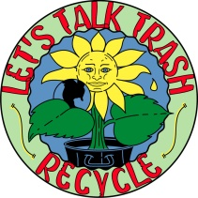
Town Hall
