PRESS RELEASE

FOR IMMEDIATE RELEASE CONTACT: NANCY HEINEMANN
May 24, 2021 President
Franconia Area Heritage Council
heritagemuseum@myfairpoint.net

KIM COWLES
Town Administrator, Franconia
townadmin@franconianh.org
603-823-7752

FRANCONIA, New Hampshire. The Franconia Selectmen and the Franconia Area Heritage Council met today to dedicate the new bronze plaque commemorating the 136 Franconia veterans serving in World War II between 1941 and 1945.

A previous plaque constructed of wood with painted letters had been dedicated in 1947, but by 2006 it had fallen into disrepair. The Franconia Area Heritage Council decided to take on the project and replace the plaque with one that could hold up to the elements and not degrade over time. Board members Phil Krill and Ernest Hansberger worked with the Lincoln Sign Company, recommending a cast bronze plaque for its longevity. Board member Eileen Ball volunteered to research all of the names on the plaque and to ensure that this list was all-inclusive. There were two criteria to be included on the plaque: one had to have been born in Franconia, Sugar Hill or Easton, or resided in Franconia, Sugar Hill and Easton and joined the conflict between 1941 and 1945.

In 2020, the work began on the cast, funded by the Franconia Area Heritage Council and one generous anonymous resident. On Thursday, May 20, the plaque--weighing over 500 pound--was hung on the south portico of the Franconia Town Hall and on Monday, May 23, the selectmen of Franconia and board members of the museum gathered to commemorate the veterans and dedicate the plaque to the town.

On Monday’s dedication, Eileen Ball highlighted a few of the personal stories that her research unearthed. Many of those listed had impressive skiing backgrounds including Dow Academy athletes, college ski team captains, instructors at Pecketts-on-Sugar Hill, directors of the Franconia Ski School, and members of the 10th Mountain Division. Five brothers of the Brooks family served during this conflict, as did five brothers of the Harriman family, three Davis brothers and three Herbert brothers. Two women served as well: Phyllis R. Downing and Dorothy Meigs.

Select Chair Jill Brewer thanked the volunteers, and noted that the plaque and the museum’s research can be starting points for area students to understand more about the courage and commitment of the people who served during this five-year period. Kim Cowles, town administrator remarked that “The plaque looks beautiful hanging at the town hall and we can be proud it was meticulously researched and designed. This effort was well overdue and the end result very much appreciated.”

The plaque can be viewed on the wall of the South Portico at the Franconia Town Hall. The original research will be archived at the Franconia Heritage Museum at 533 Main Street, open starting May 29 and on Saturdays from 1-4 pm through the fall.

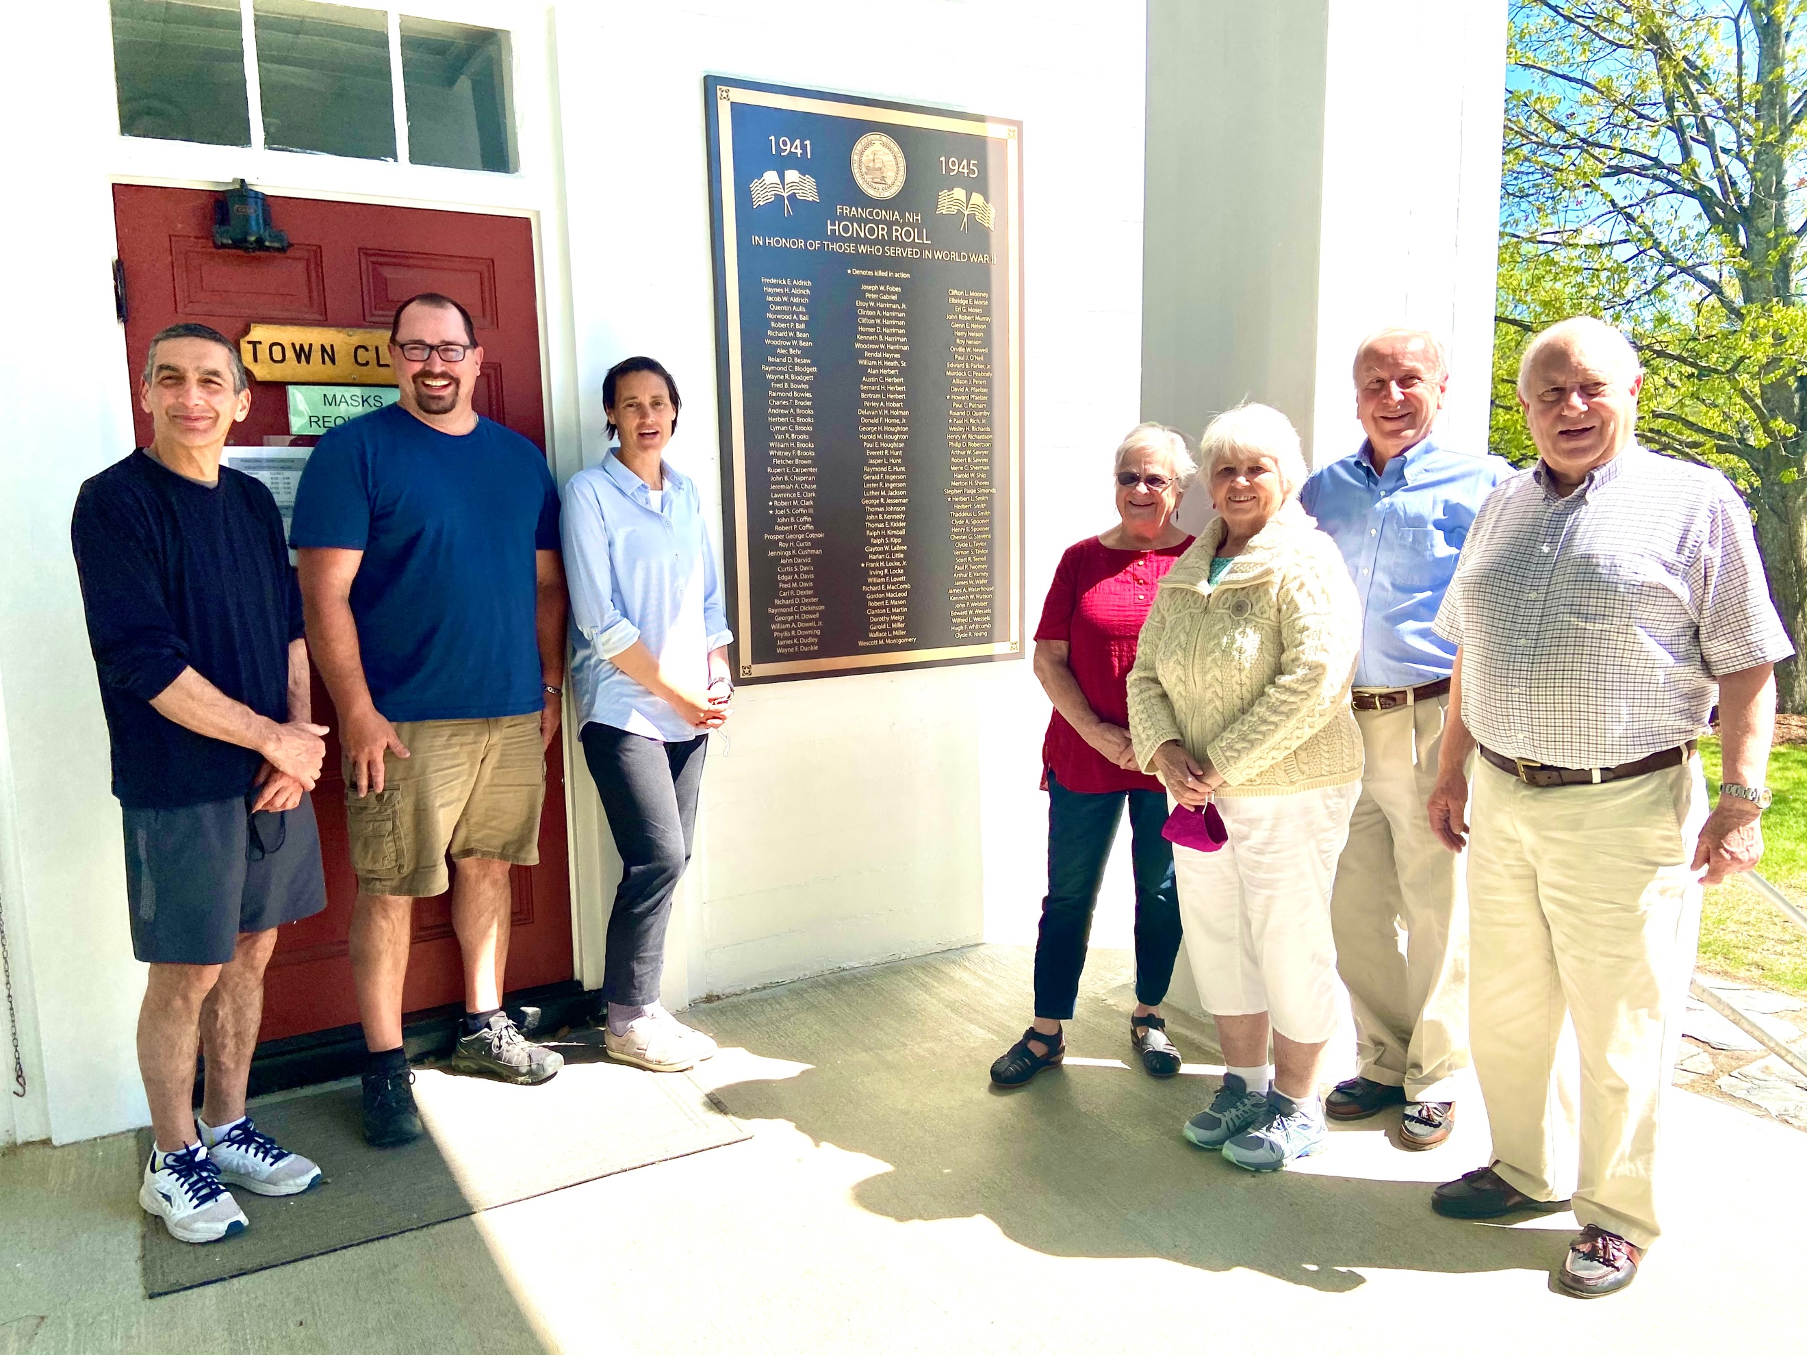

Selectmen Eric Meth, Dan Walker, Chair Jill Brewer
Franconia Area Heritage Council Board members Dot Wiggins, Eileen Ball, Phil Krill and Ernie Hansberger

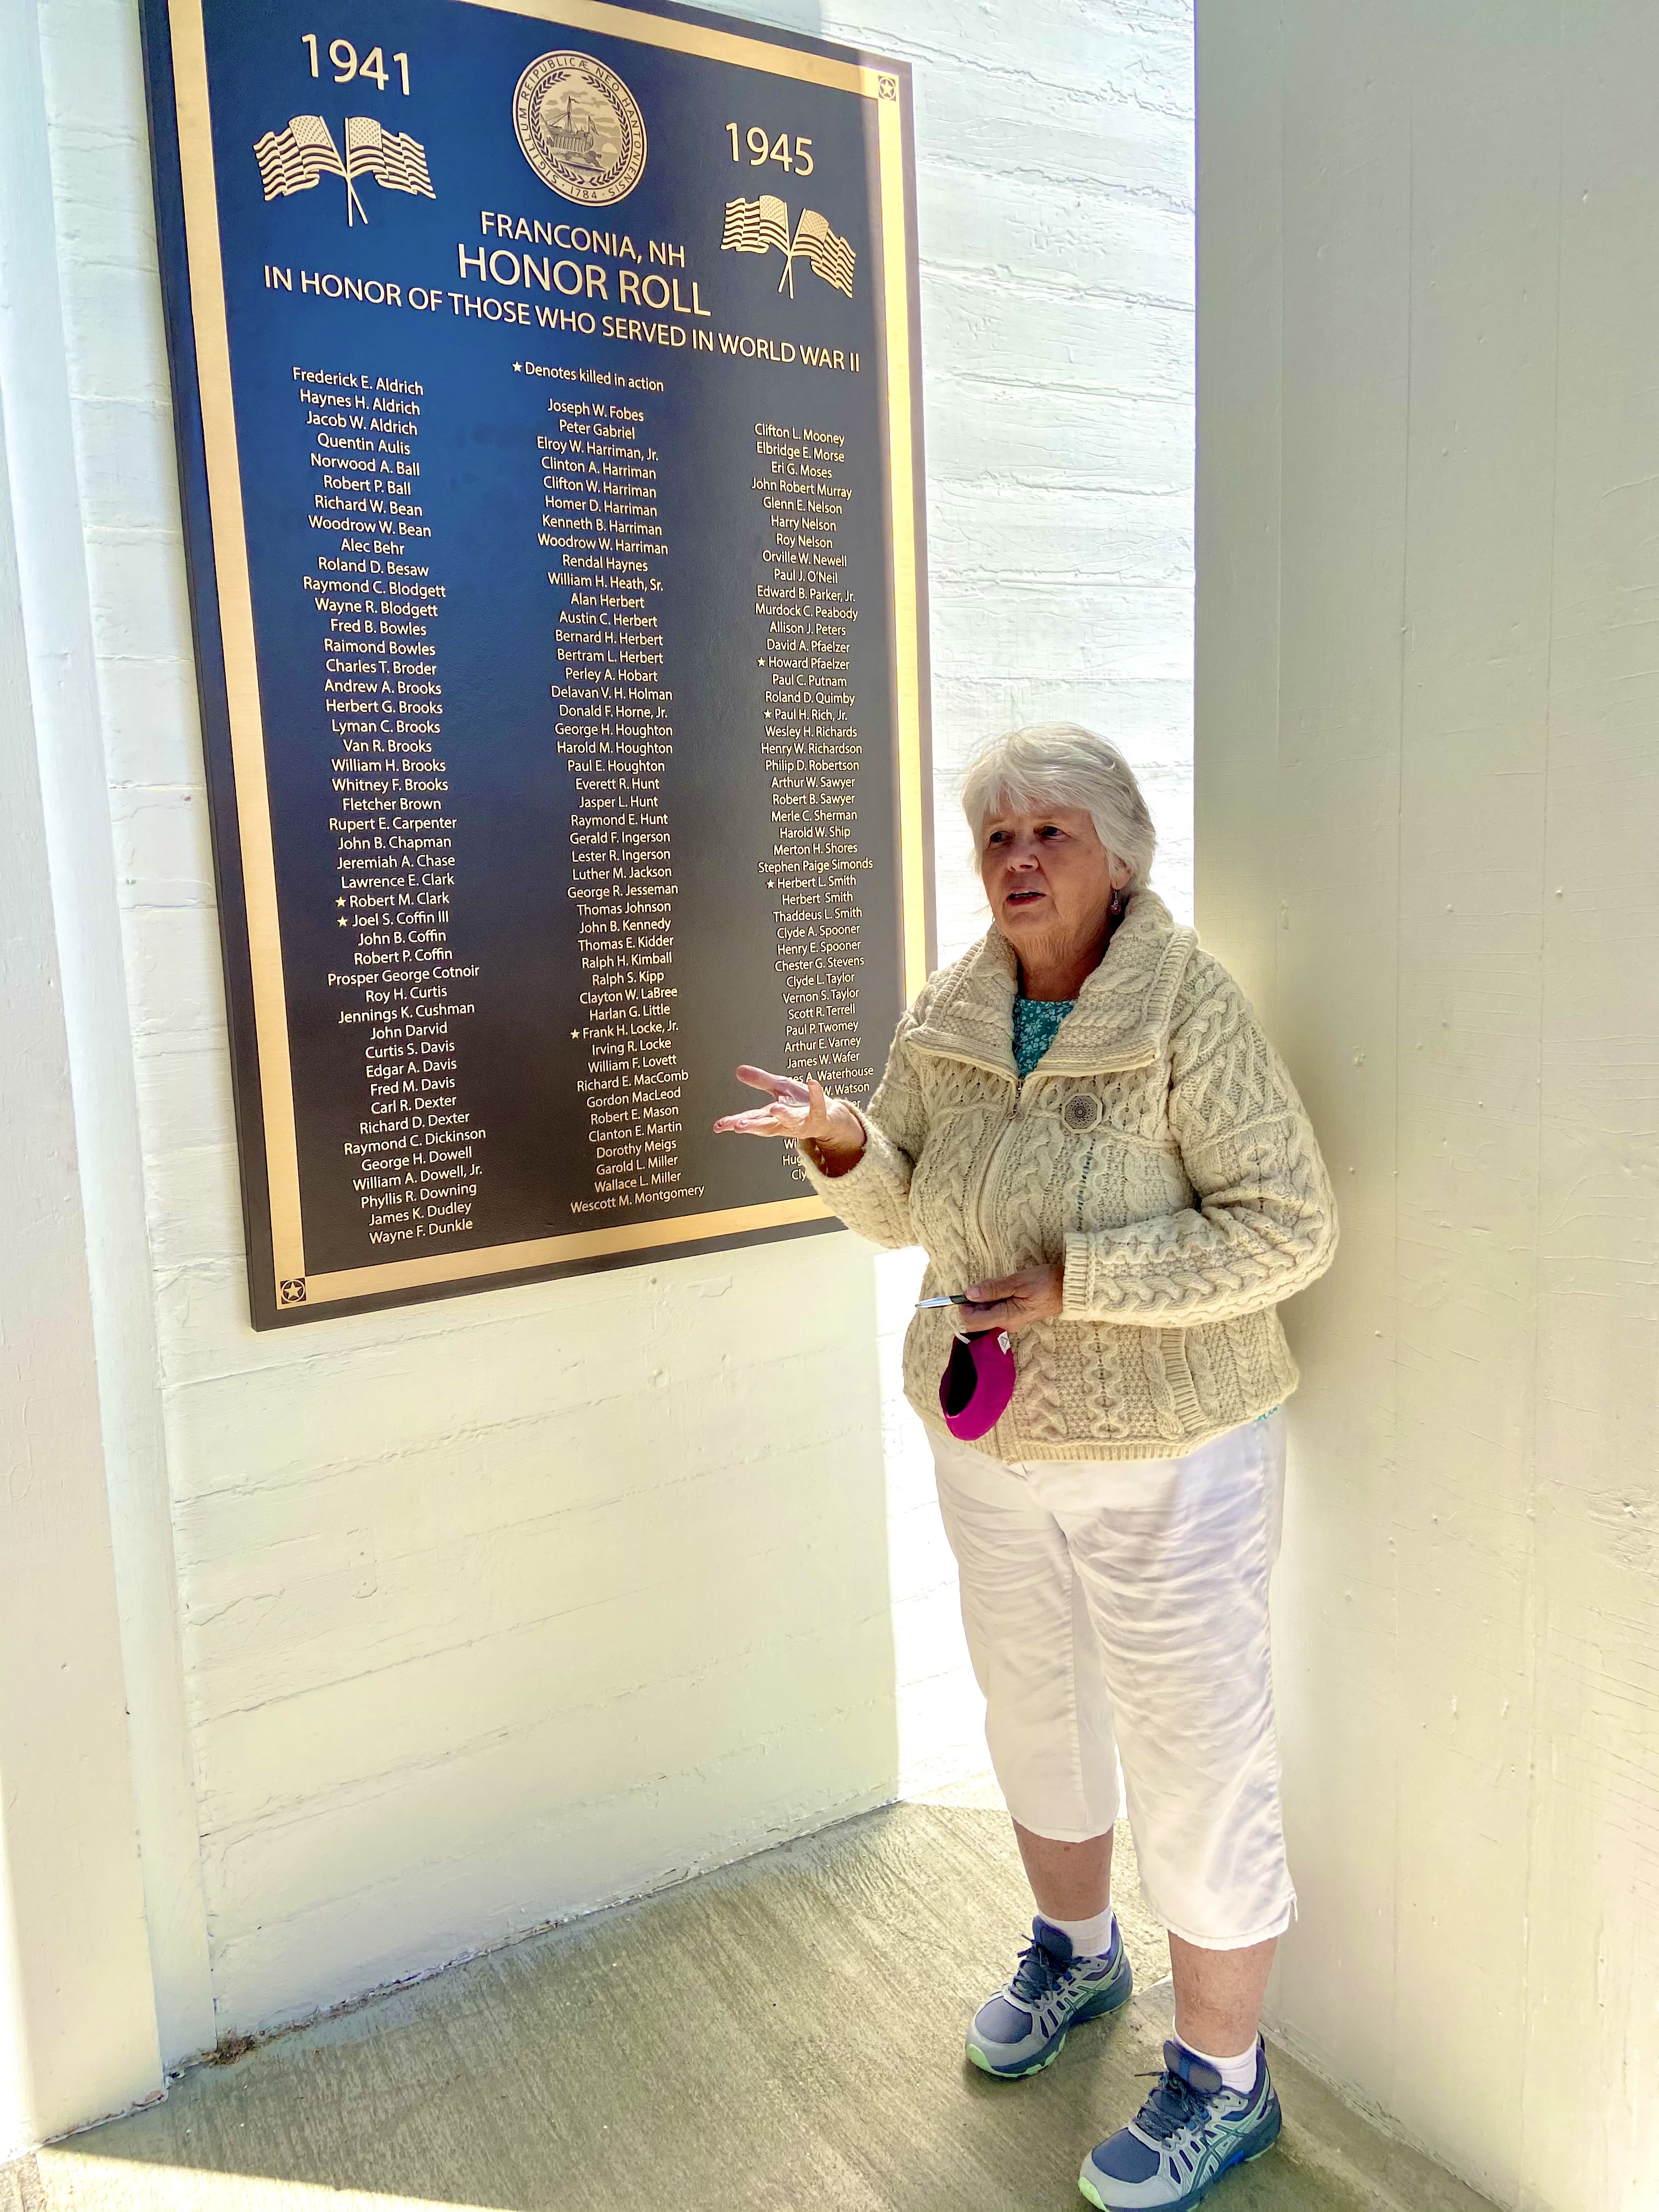
Eileen Ball, primary researcher, sharing a few of the life stories of the 136 people commemorated on the plaque.

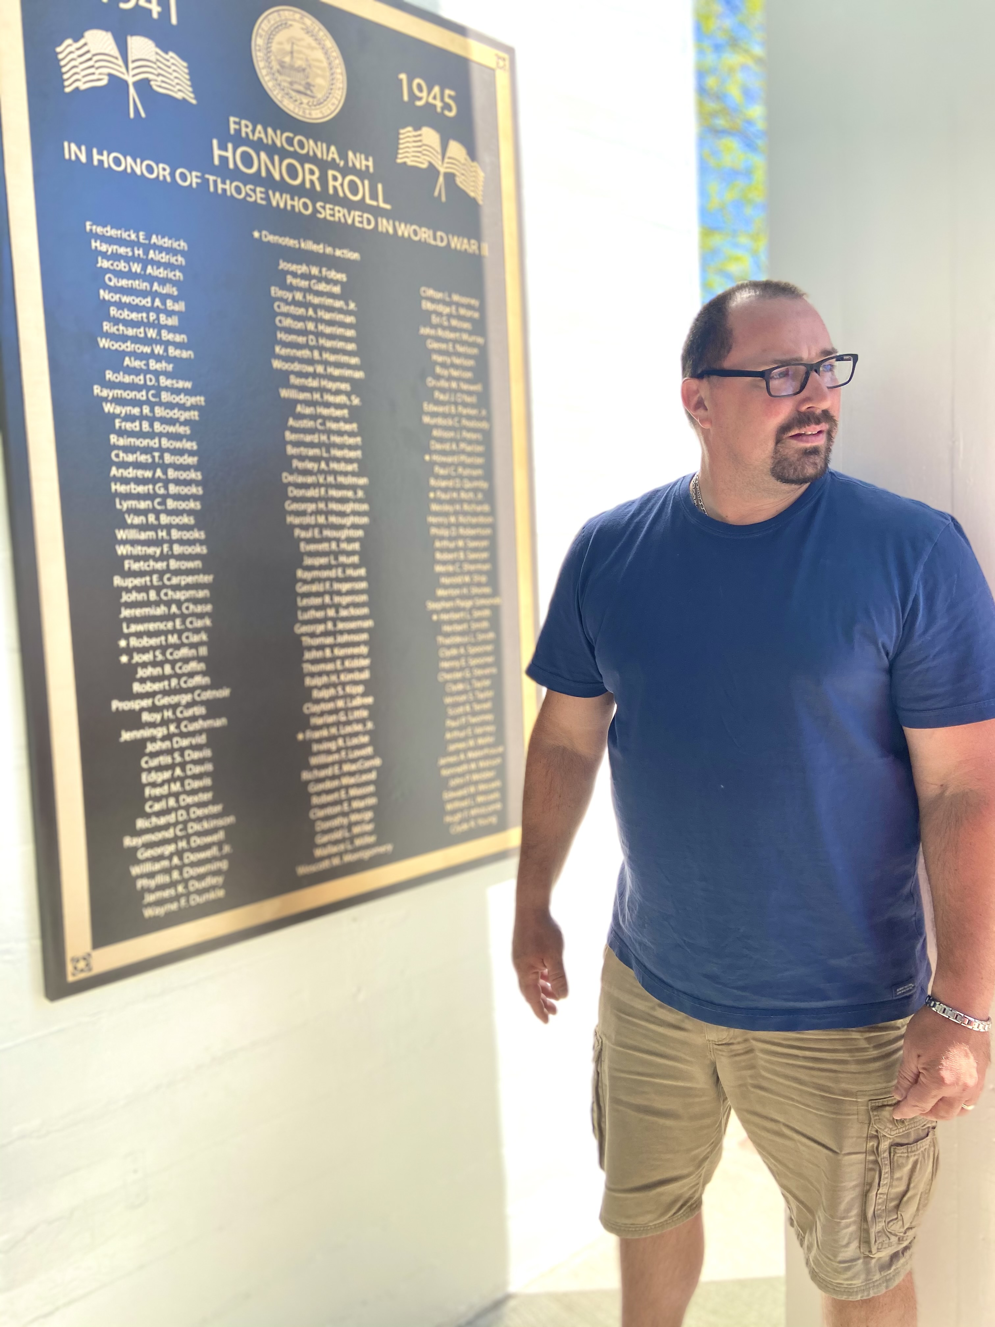
Selectman Dan Walker was surprised at the large number of people in the area who served during these five years, noting that during the war years, the town must have looked and felt very different.

